**Please enter the following:**

Class Time: Team (Table) No. Trio Letter (A, B, or C): Recorder:

**ALA – ANIMAL FORM AND FUNCTION**

Please work on this **in trios**. Add your answers to this file (please keep it as a Word file if possible—convert to PDF if you are unable to save as a Word file. **Mac user? Please do NOT submit ALAs as a “Pages” file**.), **save to desktop or some other location**, then attach when submitting your assignment through Blackboard **(be sure you submit this assignment ONLY when you are asked to do so during class)**. Only one person **per trio** should submit. All team members should write a copy of your answers so you have them to study from (or the recorder might email the completed file to other members of your trio). You may use your book, internet, or any other resources you wish to answer these questions. Be sure to ask Dr. C or one of the teaching assistants if you need help!

1. Four types of tissues are found in adult animals. Identify each of the four fundamental tissues below.

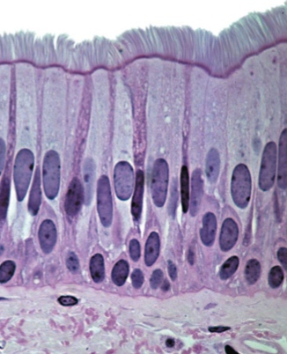 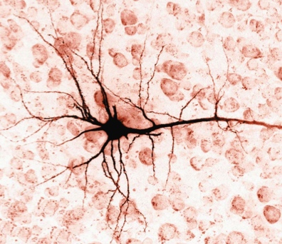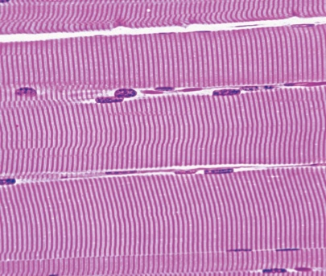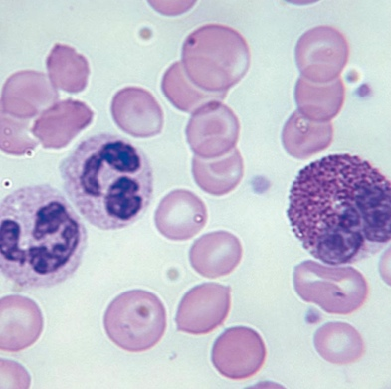

**B**

**C**

**D**

**A**

A=

B=

C=

D=

The relationship between surface area and volume is a profoundly important physiological consideration. The results below illustrate the amount of oxygen absorbed through skin and through gills in salmon from the time they first hatch from eggs (larvae) to later stages of development (juveniles).

1. What observations can be made regarding the relative importance of skin versus gills as the fish grow and develop?
2. How can you explain these results?
3. Identify at least three parts of your body that contain an extremely large surface area.

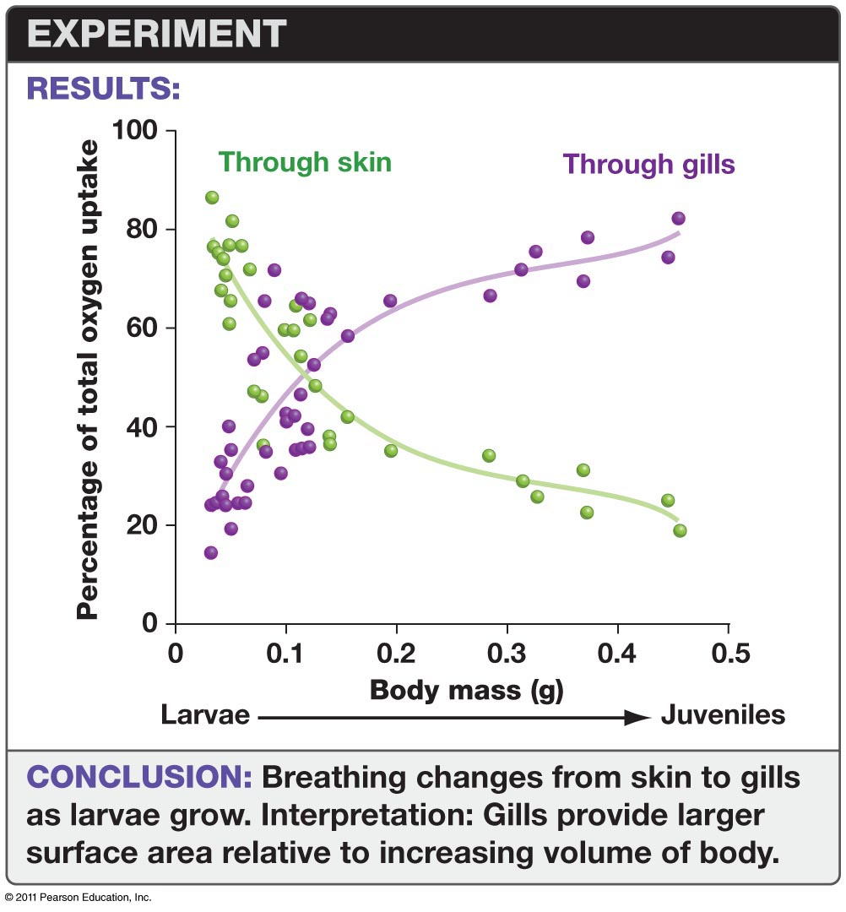

Fluids moving through various blood vessels, tubules, or ducts are often found adjacent to other fluids moving throughout the body. For example, consider arteries and veins in the whale tongue below. Note that arteries are surrounded by veins. Also note that arteries carry warm blood throughout the tongue and there is the potential for a significant amount of heat loss from the arterial blood.

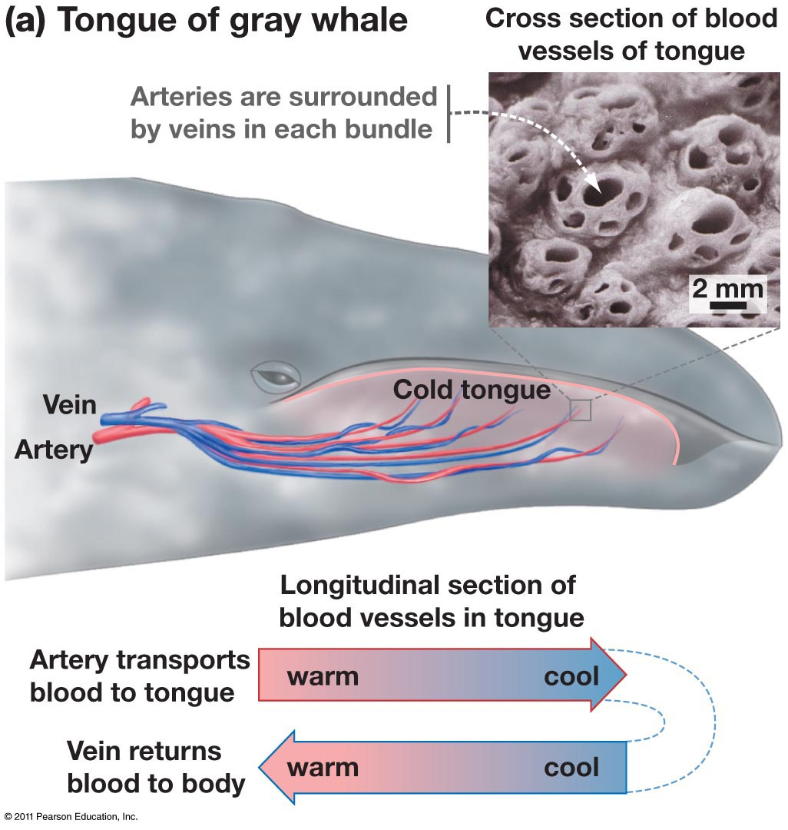

The “concurrent” diagram below illustrates what would happen if arteries and veins carried blood in the same direction.

1. Overall, how does the temperature at the end of the vein compare with the temperature at the beginning of the artery? Could the venous blood get any warmer than 30o? Explain.
2. What would the venous temperatures look like if the blood in veins was flowing in the OPPOSITE direction (i.e., “countercurrent” flow)? How might this contribute to heat conservation?

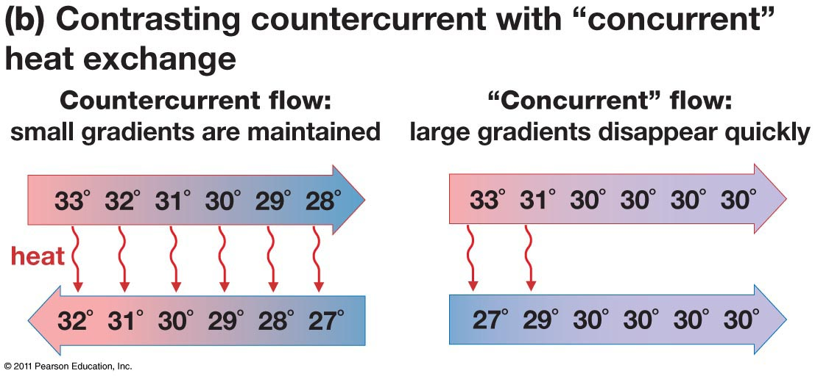

Vein

Artery

Negative feedback (or feedback inhibition) is involved in regulating homeostasis in many physiological responses. There are examples of positive feedback as well. For each of the following, identify whether they represent positive or negative feedback.



Response

Time



Response

Time

1. Drinking saltwater – the more you drink, the more you thirst.

1. Body temperature maintained at 98.6
2. Oxytocin stimulates uterine contractions in pregnant women. Uterine contractions stimulate the release of oxytocin.
3. ATP inhibits phosphofructokinase (one of the enzymes involved in glycolysis).

**Does the amount energy spent on the immune system have an impact on the reproductive system?**

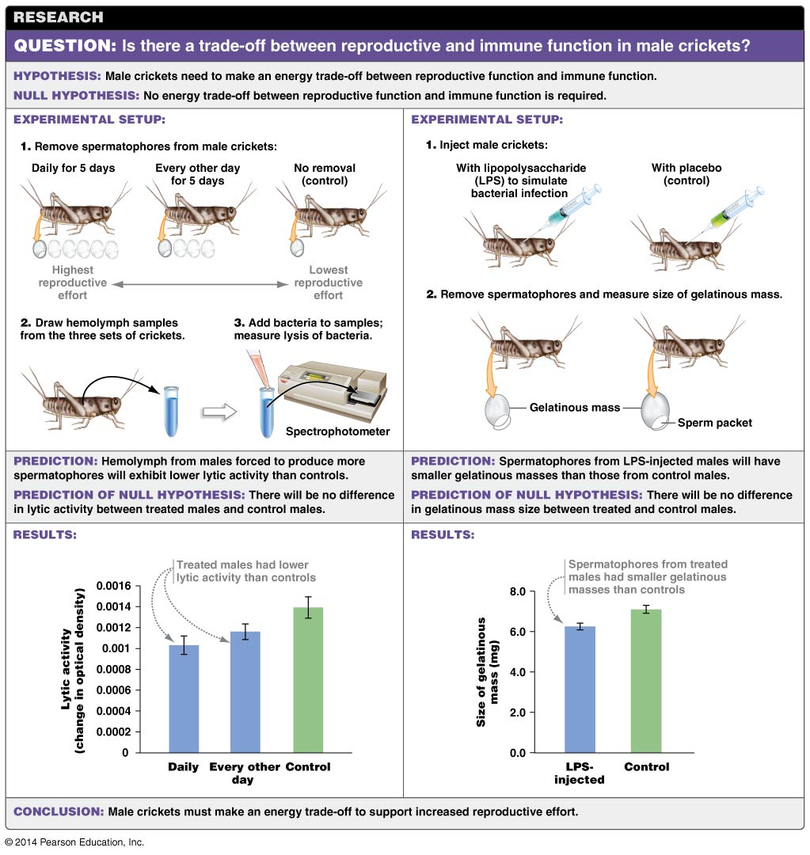

1. Consider the experiments outlined above that address the relationship between an organism’s ability to fight off bacterial infections and produce sperm. What general conclusions can be drawn?

1. The graphs below are essentially reproductions of the results shown above. Modify the data in each graph to show what the results would look like if the null hypothesis were supported by the results.

Note- Modify the data as follows:

* Click once inside one of the large boxes below.
* Choose “Charts” above, then “Edit” (shown directly below “charts”), “Edit data in Excel”.
* Change your data numbers accordingly.
* Close the Excel window.
* Your new data should now be reflected in the graphs.

**How does gigantism affect the physiology of animals?**

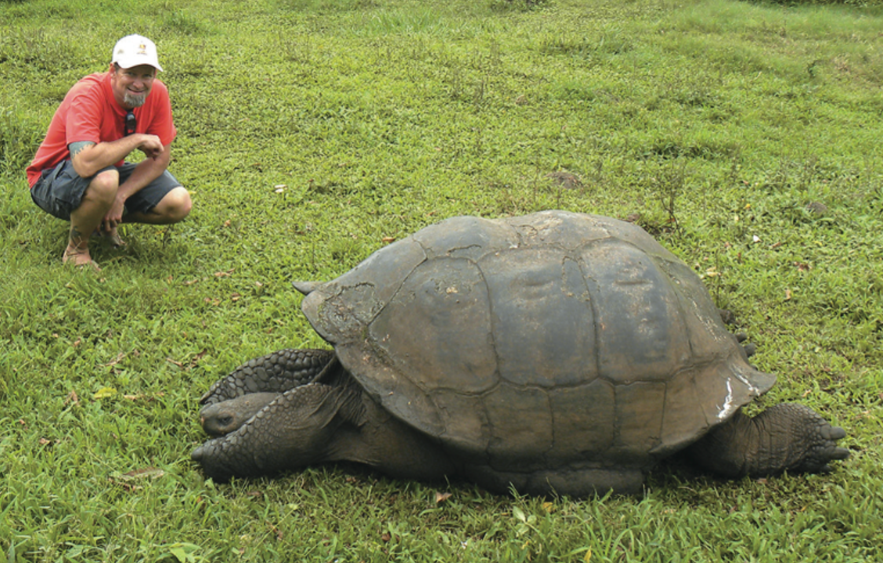

Many species of animals on islands are larger than related species on the mainland. Scientists hypothesize that this phenomenon, called island gigantism, evolved in response to the scarcity of competitors and predators on islands. Reduced competition and predation allows species to exploit more resources and frees them from the need to hide in small refuges.

QUANTITATIVE: The graph shown here compares the average carapace (shell) length of mainland and island tortoises.

1. Based on these data, evaluate whether the surface area/volume ratio is higher in mainland or island tortoises.

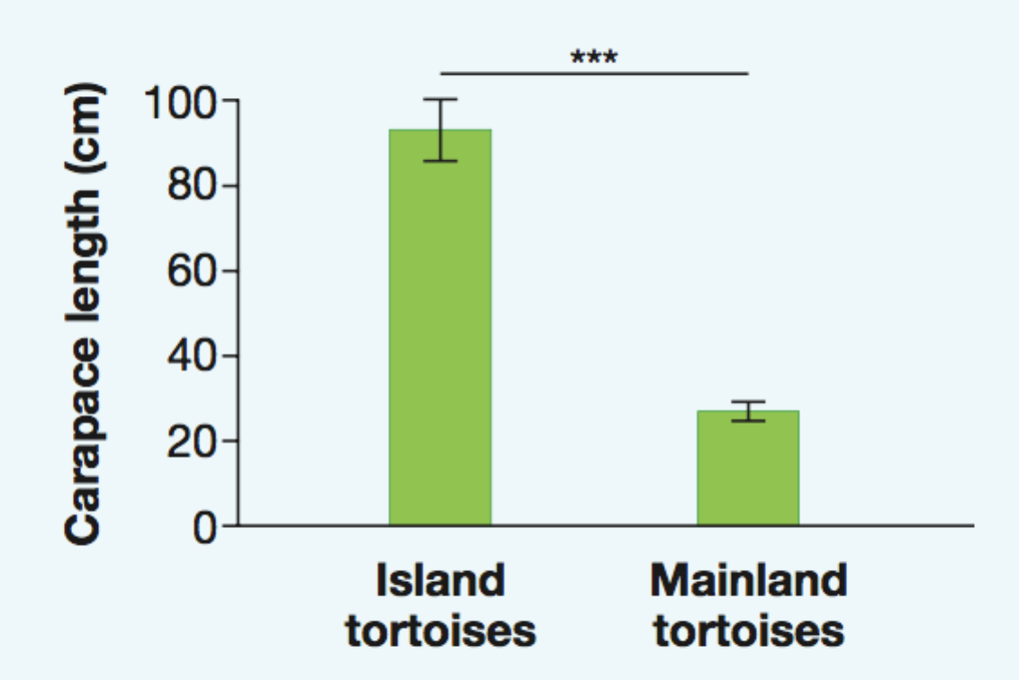

*Source:* Jaffe, A. L., G. J. Slater, and M. E. Alfaro. 2011. *Biology Letters* 7: 558–561.

1. Which tortoises, mainland or island, probably need to eat more food per gram of their body mass?

1. Suppose that a small tortoise from mainland Ecuador and a large tortoise from the Galápagos Islands are placed in the same pen at a zoo. Which tortoise will be more poikilothermic, the small or large tortoise? Why?

1. On a trip to the Galápagos Islands, you overhear a group of tourists refer to tortoises as “cold blooded.” Explain why this word is not accurate to describe a giant tortoise.